Computer networks

**Lab activity – 6**

**Name :** N.V.M.Sumanth

**Reg no :** 192111449

**Faculty :** Dr. S. Ramesh

**Course code :** CSA0786 computer networks for wanet applications

**Lab activity : 6**

**Question : Static Routing using Packet Tracer.**

**Step 1 : Take four computers**

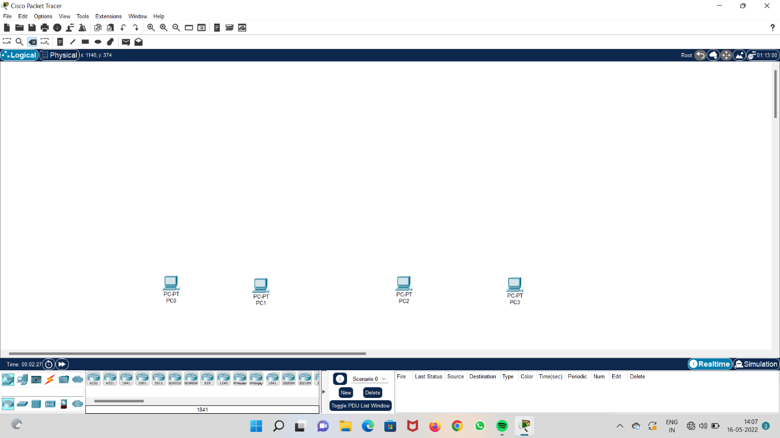

**Step 2 : take two switches and two routers and connect the network**

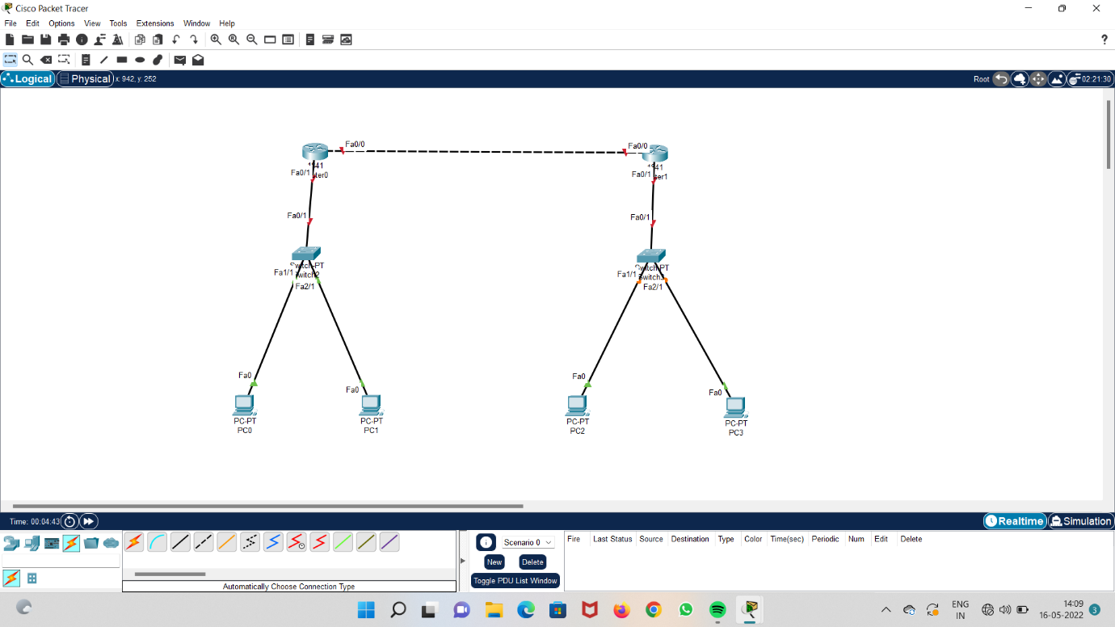

**Step 3 : add IP address to the systems**

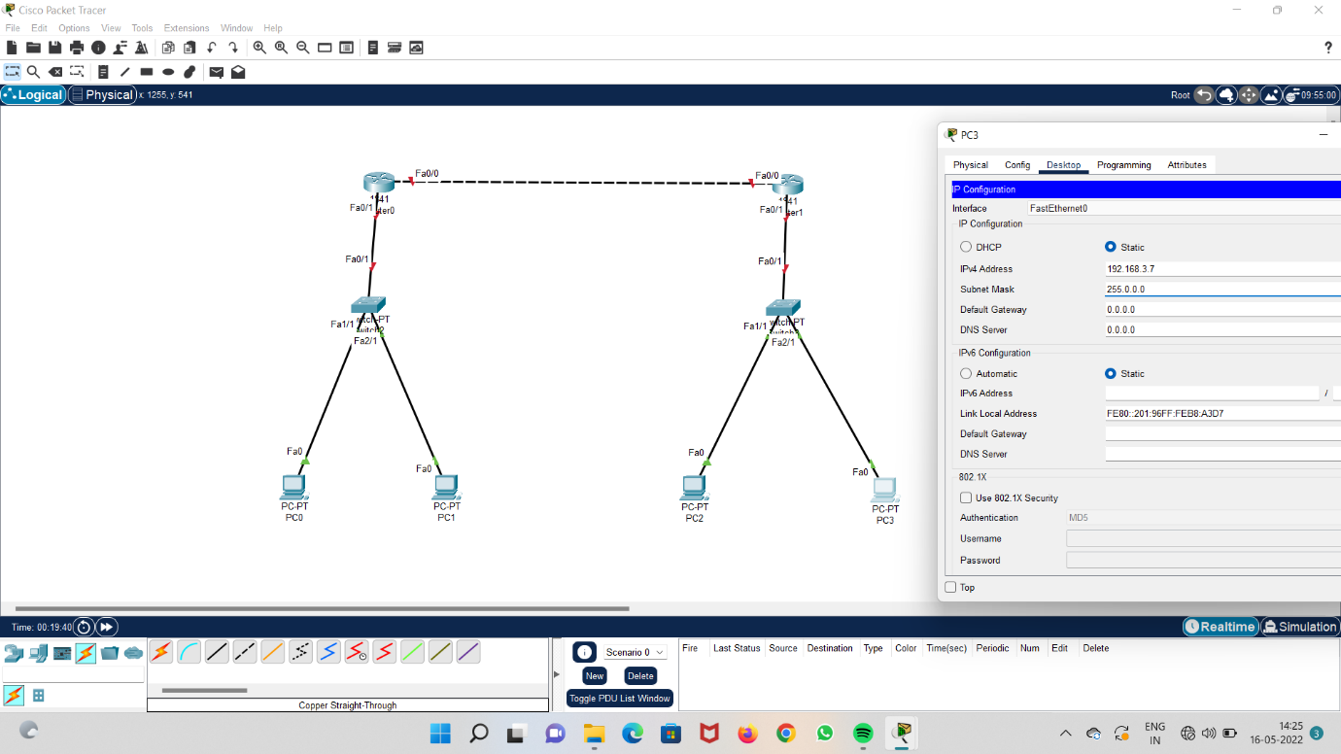

**Step 4 : open configuration in routers and give ipv4 address and subnet address to the routers**

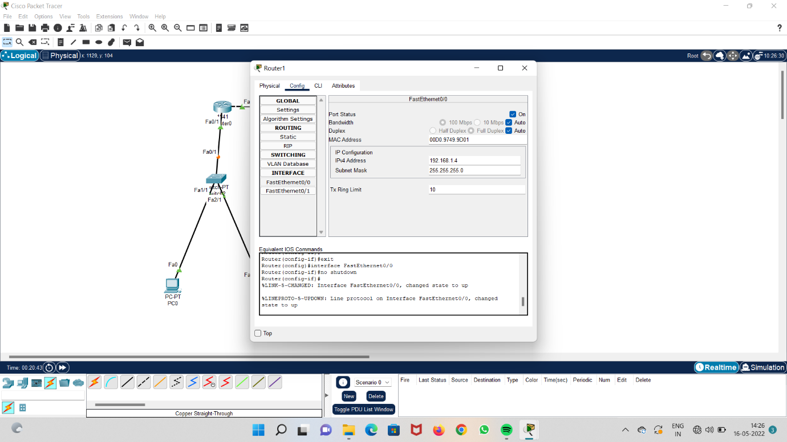

**Step 5 : check routing table for systems**

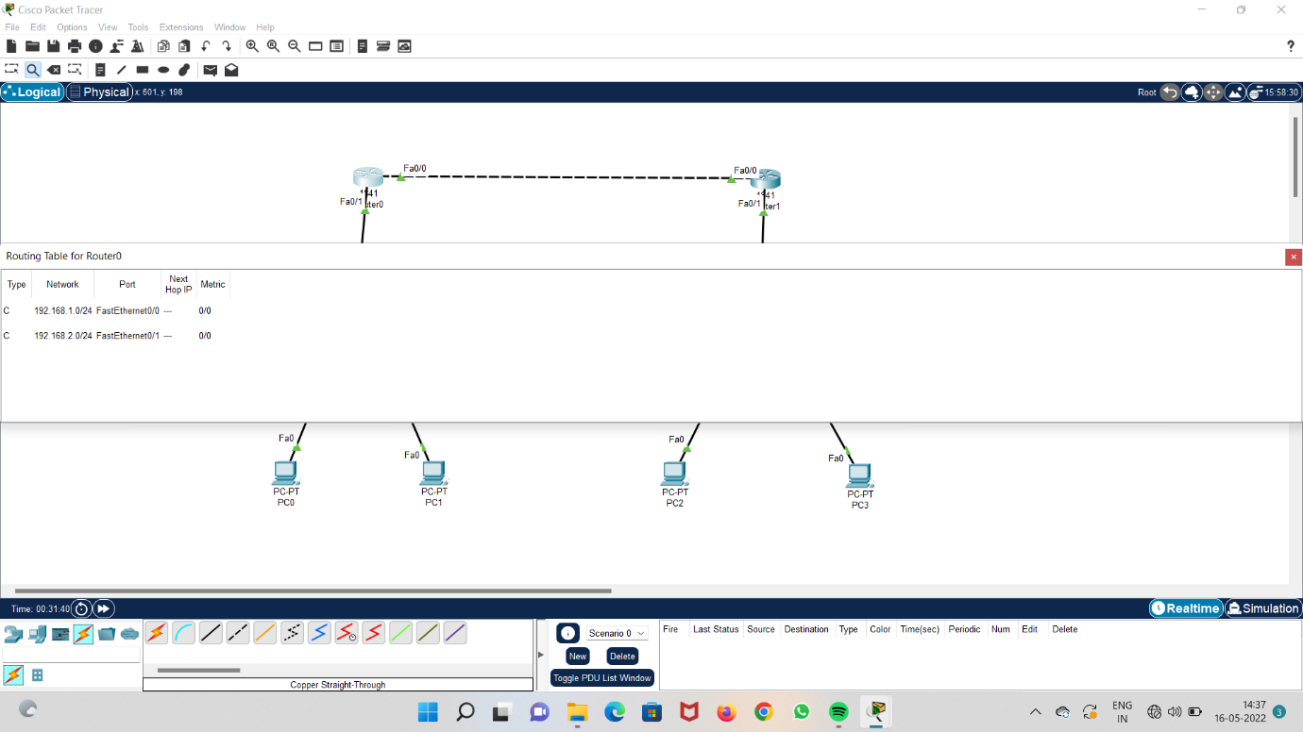

**Step 6 : open static in router configuration and enter network address, subnet mask and next hop.**

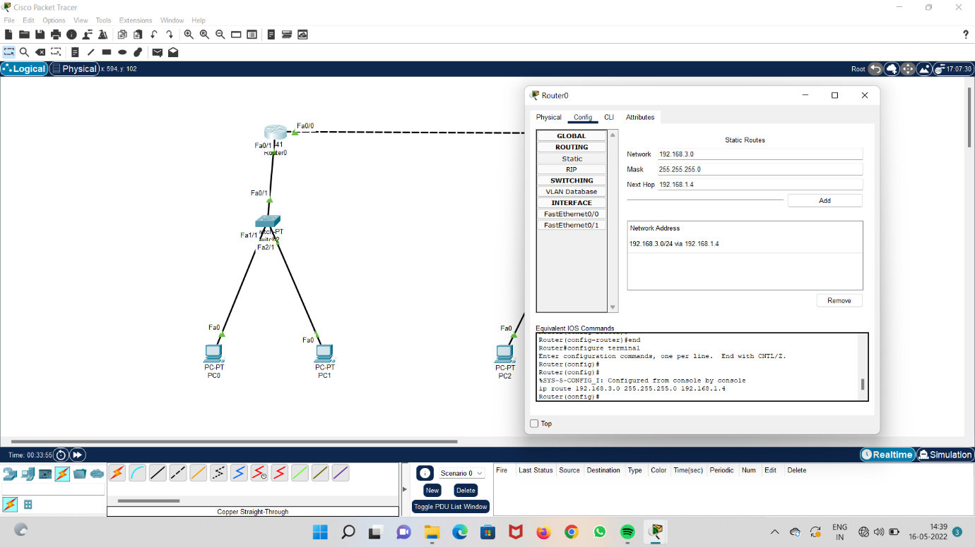

**Step 7 : check for s type in routing table**

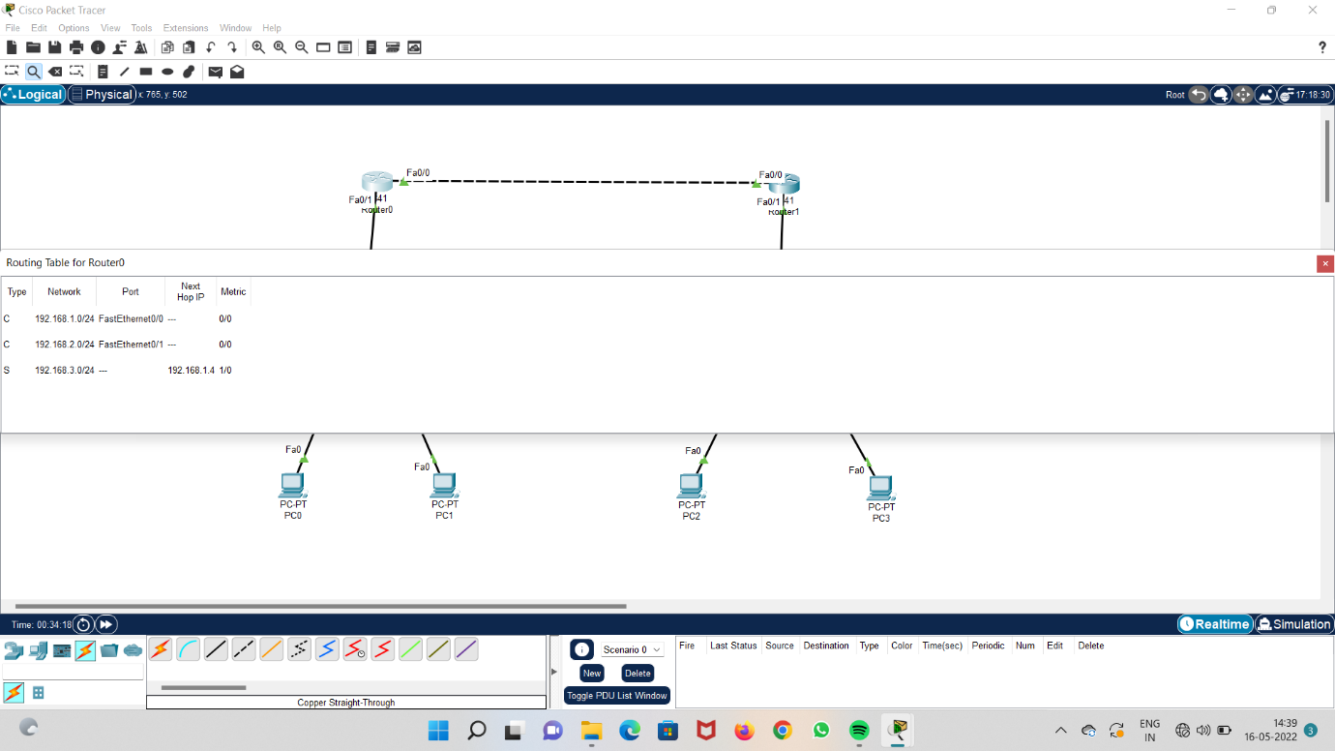

**Step 8 : Run the system and check acknowledgement**

